# Question_1:

## Coding:

import org.openqa.selenium.By;

import org.openqa.selenium.WebDriver;

import org.openqa.selenium.chrome.ChromeDriver;

import org.openqa.selenium.chrome.ChromeOptions;

import io.github.bonigarcia.wdm.WebDriverManager;

public class question_1 {

public static void main(String[] args) throws InterruptedException {

ChromeOptions co = new ChromeOptions();

co.addArguments("--remote-allow-origins=*");

WebDriverManager.chromedriver().setup();

WebDriver driver = new ChromeDriver();

driver.get("https://www.saucedemo.com/");

driver.manage().window().maximize();

Thread.sleep(3000);

driver.findElement(By.xpath("//*[@id=\"user-name\"]")).sendKeys("standard_user");

driver.findElement(By.xpath("//*[@id=\"password\"]")).sendKeys("secret_sauce");

// Thread.sleep(3000);

driver.findElement(By.xpath("//*[@id=\"login-button\"]")).click();

Thread.sleep(3000);

driver.findElement(By.xpath("//*[@id=\"add-to-cart-sauce-labs-backpack\"]")).click();

Thread.sleep(3000);

Boolean bo1 = driver.findElement(By.xpath("//*[@id=\"shopping_cart_container\"]/a/span")).isDisplayed();

//case 1

if(bo1 == true){

System.out.println("Case 1:Passed,User can add a Product to 'Add to Cart'");

}else{

System.out.println("Case 1:Failed,User is not able to add a Product to 'Add to Cart'");

}

Thread.sleep(3000);

//Case 2

driver.findElement(By.xpath("//*[@id=\"shopping_cart_container\"]/a")).click();

Boolean bo2 = driver.findElement(By.xpath("//*[@id=\"cart_contents_container\"]/div/div[1]/div[3]")).isDisplayed();

Thread.sleep(3000);

if(bo2 == true) {

System.out.println("Case 2:Passed,Products is displayed in the Cart");

}else {

System.out.println("Case 2:Failed,Products are not displayed in the Cart");

}

Thread.sleep(3000);

//Case 3

driver.findElement(By.xpath("//*[@id=\"checkout\"]")).click();

Thread.sleep(3000);

Boolean bo3 = driver.findElement(By.xpath("//*[@id=\"header_container\"]/div[2]/span")).isDisplayed();

if(bo3==true) {

System.out.println("The text : 'Your information' is displayed,Hence Passed");

}else {

System.out.println("The text : 'Your information' is not displayed,Hence Failed");

}

//case 4

driver.findElement(By.xpath("//*[@id=\"first-name\"]")).sendKeys("fName");

driver.findElement(By.xpath("//*[@id=\"last-name\"]")).sendKeys("lName");

driver.findElement(By.xpath("//*[@id=\"postal-code\"]")).sendKeys("12345");

Thread.sleep(2000);

driver.findElement(By.xpath("//*[@id=\"continue\"]")).click();

Thread.sleep(2000);

Boolean bo4 = driver.findElement(By.xpath("//*[@id=\"header_container\"]/div[2]/span")).isDisplayed();

if(bo4==true) {

System.out.println("The text : 'Overview' is displayed,Hence Passed");

}else {

System.out.println("The text : 'Overview' is not displayed,Hence Failed");

}

String proName = driver.findElement(By.xpath("//*[@id=\"item_4_title_link\"]/div")).getText();

String proPrice = driver.findElement(By.xpath("//*[@id=\"checkout_summary_container\"]/div/div[2]/div[8]")).getText();

Thread.sleep(3000);

System.out.println("ProductName: "+proName);

System.out.println("ProductPrice: "+proPrice);

String url = "https://www.saucedemo.com/checkout-step-two.html";

String title = "Swag Labs";

String actitle = driver.getTitle();

String acurl = driver.getCurrentUrl();

Thread.sleep(4000);

if(title==actitle) {

System.out.println("TitleMatched");

}else {

System.out.println("UnMatchedTitle");

}

Thread.sleep(3000);

if(url==acurl) {

System.out.println("UrlMatched");

}else {

System.out.println("UnMatchedUrl");

}

Thread.sleep(2000);

driver.quit();

}

}

## Output:

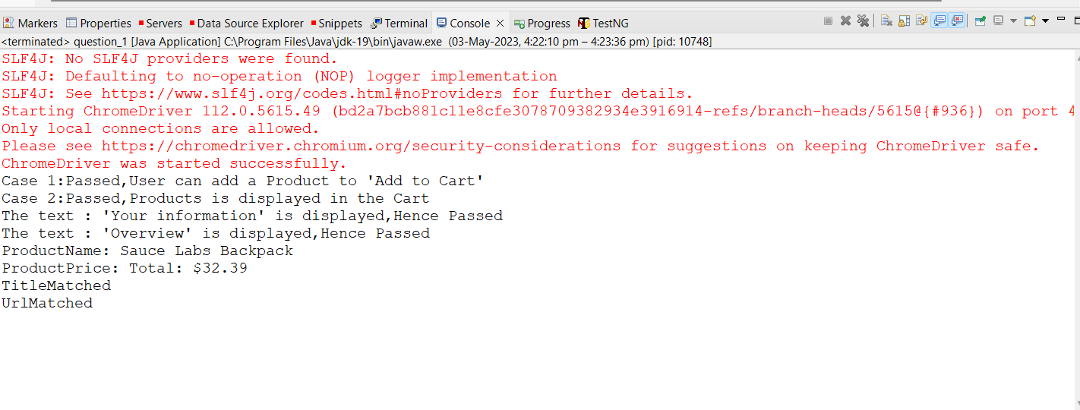

# Question_2:

## Coding:

import java.util.ArrayList;

import java.util.Collections;

import java.util.List;

import org.openqa.selenium.By;

import org.openqa.selenium.WebDriver;

import org.openqa.selenium.WebElement;

import org.openqa.selenium.chrome.ChromeDriver;

import org.openqa.selenium.chrome.ChromeOptions;

import org.openqa.selenium.support.ui.Select;

import io.github.bonigarcia.wdm.WebDriverManager;

public class question_2 {

public static void main(String[] args) throws InterruptedException {

ChromeOptions co = new ChromeOptions();

co.addArguments("--remote-allow-origins=*");

WebDriverManager.chromedriver().setup();

WebDriver driver = new ChromeDriver();

driver.get("https://www.saucedemo.com/");

driver.manage().window().maximize();

driver.findElement(By.xpath("//*[@id=\"user-name\"]")).sendKeys("standard_user");

driver.findElement(By.xpath("//*[@id=\"password\"]")).sendKeys("secret_sauce");

Thread.sleep(4000);

driver.findElement(By.xpath("//*[@id=\"login-button\"]")).submit();

Thread.sleep(4000);

List<WebElement> items = new ArrayList<WebElement>();

List<String> products = new ArrayList<String>();

Select select = new Select(driver.findElement(By.xpath("//*[@id=\"header_container\"]/div[2]/div/span/select")));

String sortingOrder = select.getFirstSelectedOption().getText();

items = driver.findElements(By.className("inventory_item_name"));

for(WebElement element: items) {

products.add(element.getText());

}

if(sortingOrder.equals("Name (A to Z)")) {

Collections.sort(products);

for(int i=0; i<items.size(); i++) {

if(!products.get(i).equals(items.get(i).getText())) {

System.out.println("Not in sorted order");

break;

}

}

System.out.println("In sorted Order");

System.out.println(items.get(0).getText());

}

if(sortingOrder.equals("Name (Z to A)")) {

Collections.sort(products, Collections.reverseOrder());

for(int i=0; i<items.size(); i++) {

if(!products.get(i).equals(items.get(i).getText())) {

System.out.println("Not in sorted order");

break;

}

}

System.out.println("In sorted Order");

System.out.println(items.get(0).getText());

}

driver.findElement(By.xpath("//*[@id=\"header_container\"]/div[2]/div/span/select")).click();

driver.findElement(By.xpath("//*[@id=\"header_container\"]/div[2]/div/span/select/option[3]")).click();

String price = driver.findElement(By.xpath("//*[@id=\"inventory_container\"]/div/div[1]/div[2]/div[2]/div")).getText();

if(price.equals("$7.99")) {

System.out.println("price sorted order (A-Z)");

}

driver.findElement(By.xpath("//*[@id=\"header_container\"]/div[2]/div/span/select")).click();

driver.findElement(By.xpath("//*[@id=\"header_container\"]/div[2]/div/span/select/option[4]")).click();

String price2 = driver.findElement(By.xpath("//*[@id=\"inventory_container\"]/div/div[1]/div[2]/div[2]/div")).getText();

if(price2.equals("$49.99")) {

System.out.println("price sorted order (Z-A)");

}

}

}

## Output:

